**Project Design Phase-II**

**Data Flow Diagram & User Stories**

| Date | 20 June 2025 |
| --- | --- |
| Team ID | LTVIP2025TMID39799 |
| Project Name | Clean Tech: Transforming waste into Transfer Learning |
| Maximum Marks | 4 Marks |

**Data Flow Diagrams:**

A Data Flow Diagram (DFD) is a traditional visual representation of the information flows within a system. A neat and clear DFD can depict the right amount of the system requirement graphically. It shows how data enters and leaves the system, what changes the information, and where data is stored.

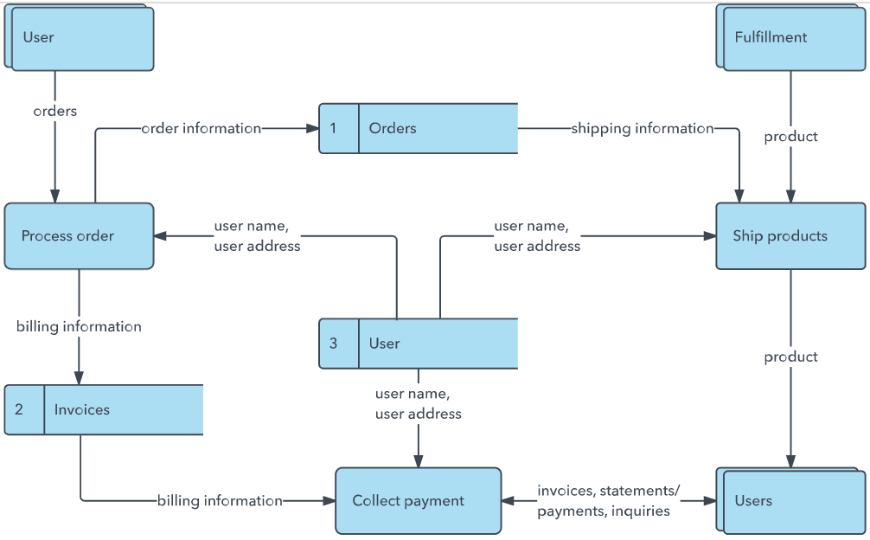

**Example:** [**(Simplified)**](https://developer.ibm.com/patterns/visualize-unstructured-text/)

**User Stories**

Use the below template to list all the user stories for the product.

| **User Type** | **Functional Requirement (Epic)** | **User Story Number** | **User Story / Task** | **Acceptance criteria** | **Priority** | **Release** |
| --- | --- | --- | --- | --- | --- | --- |
| Doctor (Web) | Blood Cell Analysis | USN-10 | As a doctor, I can upload blood sample images to classify blood cells automatically | Blood cell classification is accurate & shown | High | Sprint-1 |
| Technician  (Mobile) | Training Tool access | USN-11 | As a technician, I can view feedback after uploading images for training purposes | Classification results and educational tips shown | Medium | Sprint-2 |
| Pathologist | Image Upload & Diagnosis | USN-1 | As a pathologist, I can upload a blood cell image to receive cell classification | Classification is displayed accurately | High | Sprint-1 |
| Pathologist | Diagnostic Report | USN-2 | As a pathologist, I can generate a diagnostic report after classification | Downloadable report with cell count per type | High | Sprint-1 |
| Remote Doctor | Remote Image Submission | USN-3 | As a doctor, I can submit images remotely for analysis | Receive automated classification and report | High | Sprint-2 |
| Medical Student | Training mode | USN - 4 | As a student, I can upload sample images and receive feedback | Correct cell type and explanation are shown | Medium | Sprint - 2 |
| Admin | Dataset Management | USN - 5 | As an admin, I can manage and update the image dataset | Dataset changes are reflected in the system | Medium | Sprint-3 |
|  |  |  |  |  |  |  |
|  |  |  |  |  |  |  |
|  |  |  |  |  |  |  |
|  |  |  |  |  |  |  |
|  |  |  |  |  |  |  |